**Cấu hình DHCP**

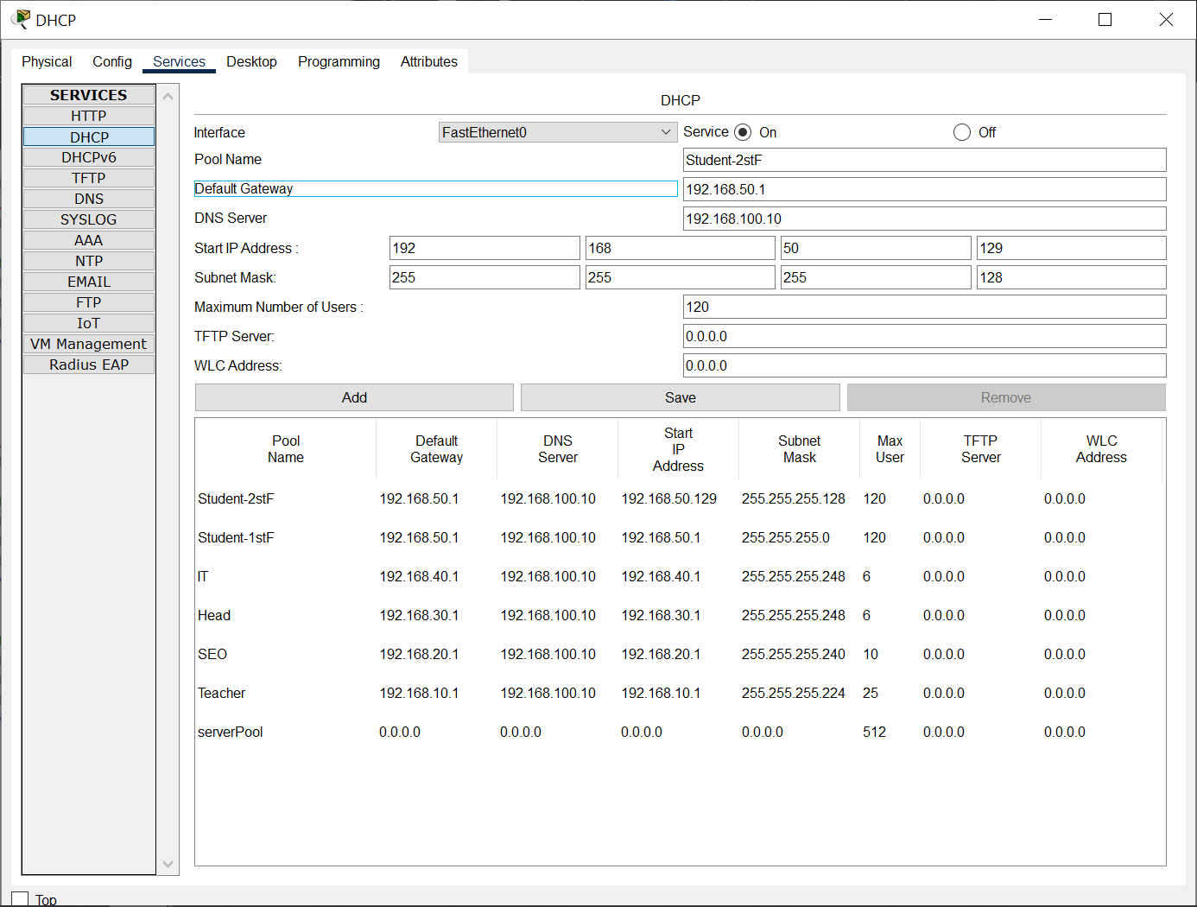

**

**Cấu hình WL-Router**

**Kiểm tra lại bằng Laptop**

